**Plan for iteration 1**

This document consists of two parts: (i) retrospect on how project work was carried out during initial phase, and (ii) a list of requirements from project plan’s MoSCoW list that the team will be working on during iteration 1.

Similarly to this, plan for iteration 2 will consist of retrospect about work done during iteration one, and a list of requirements that will be developed during iteration 2. Essentially iteration documents describe work done, and word to be done.

To sum everything up, there was some initial confusion because of the fact that the selected simulation topic was novel. However, every team member was active and involved. Members were not reluctant to express concerns, on various topics. Good discussion atmosphere was present from the start. Members are still looking for their prefered areas of work, and an initial agreement was reached that certain members will concentrate on different parts of the project, namely documentation, visualization, code logic. However, all members will produce both code and text, but to varying amounts.

1.

Retrospect

This table summarizes work done during the initial phase: all members were present and involved in the project’s initial phase, to varying degrees. Names are listed alphabetically.

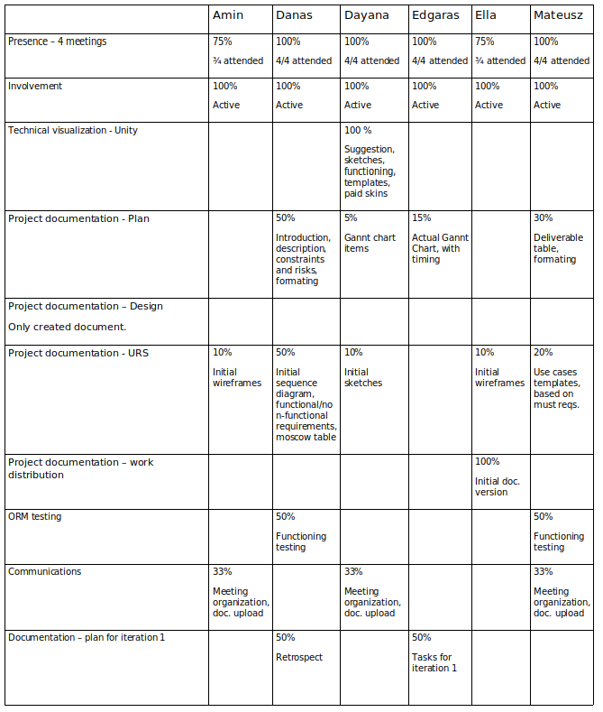

2.

List of requirements that will be worked on during iteration one. Expressed in Gannt Chart:

The goal of this text is to specify which functional requirements our team will work on. Initial parameter setting will be focused on during iteration 1. (setting budget, population, layout to be displayed, basic UI functionality). 